# INSTALLING JENKINS IN LINUX AND CREATING FREESTYLE NGINX PROJECT

STEP – 1: INSTALLING JAVA

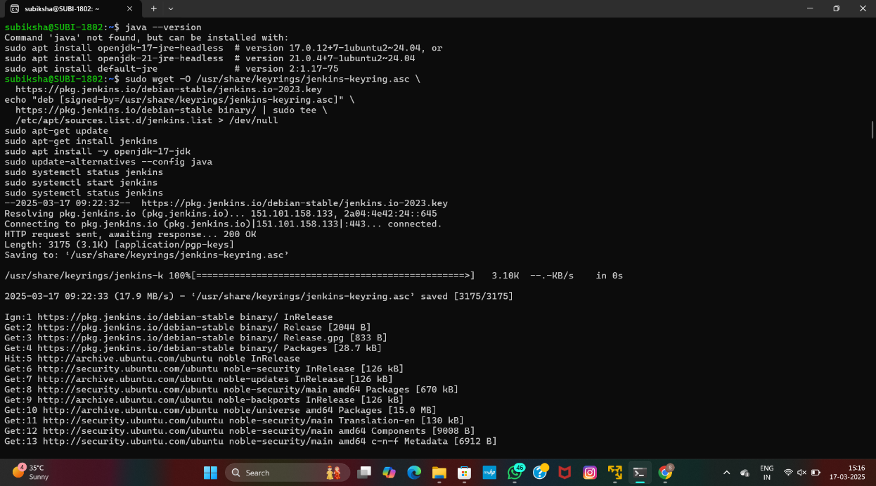

STEP – 2: INSTALLING JENKINS

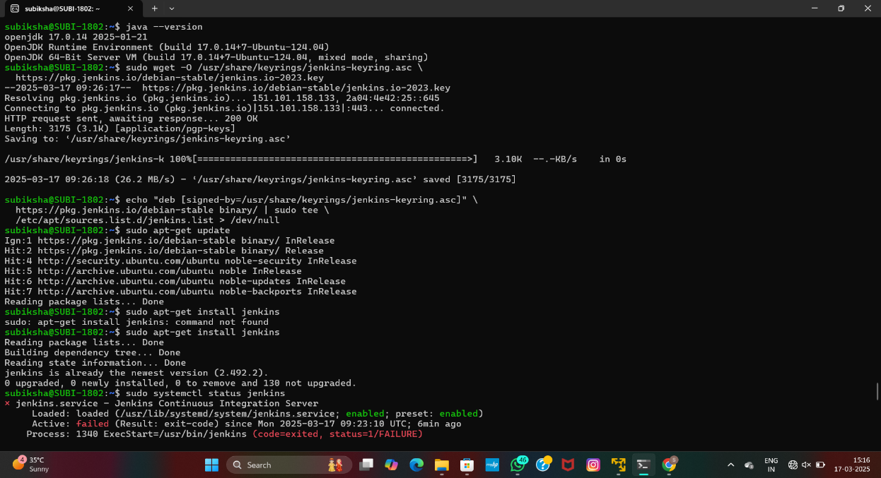

STEP – 3: ENABLING JENKINS

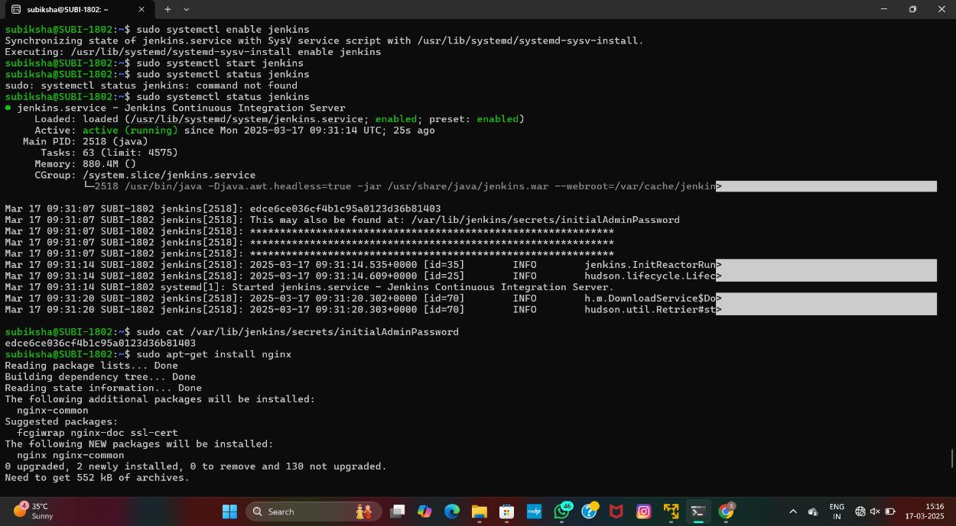

STEP – 4:INITIALISING JENKINS

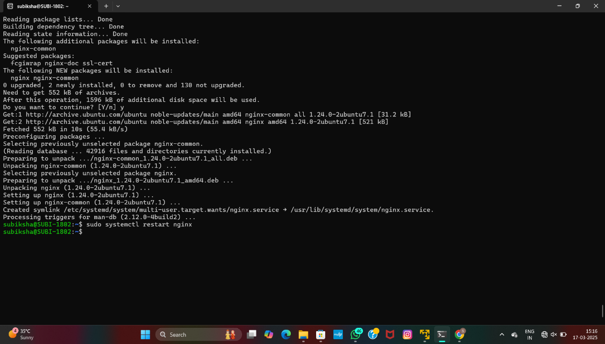

STEP – 5: OUTPUT

